Evaluation of Machine Learning Algorithms for the Detection of Fake Bank Currency

We have converted this project in DJANGO and to run project install python 3.7.0 and then install all packages from requirements.txt file

Install MYSQL database and give password as ‘root’ while installation and then copy content from DB.txt file and then paste in MYSQL console to create database

Now double click on ‘run.bat’ file to start python DJANGO server and then will get below page

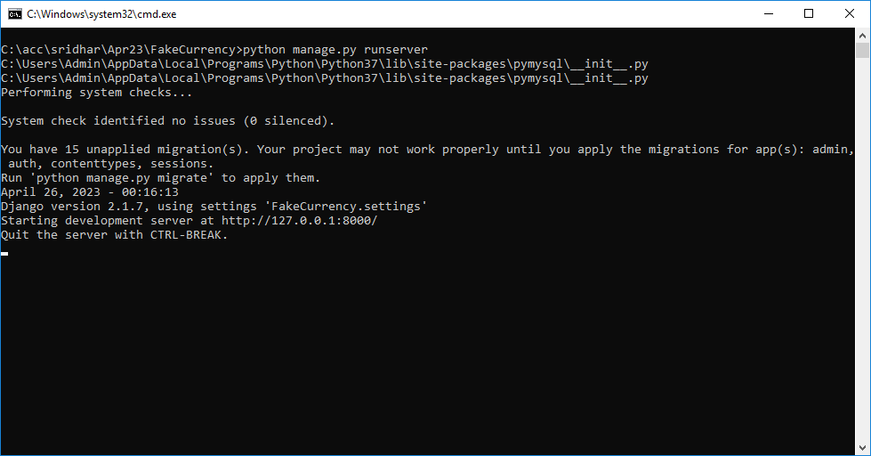

In above screen python DJANGO server started and now open bowser and enter URL as <http://127.0.0.1:8000/index.html> and press enter key to get below home page

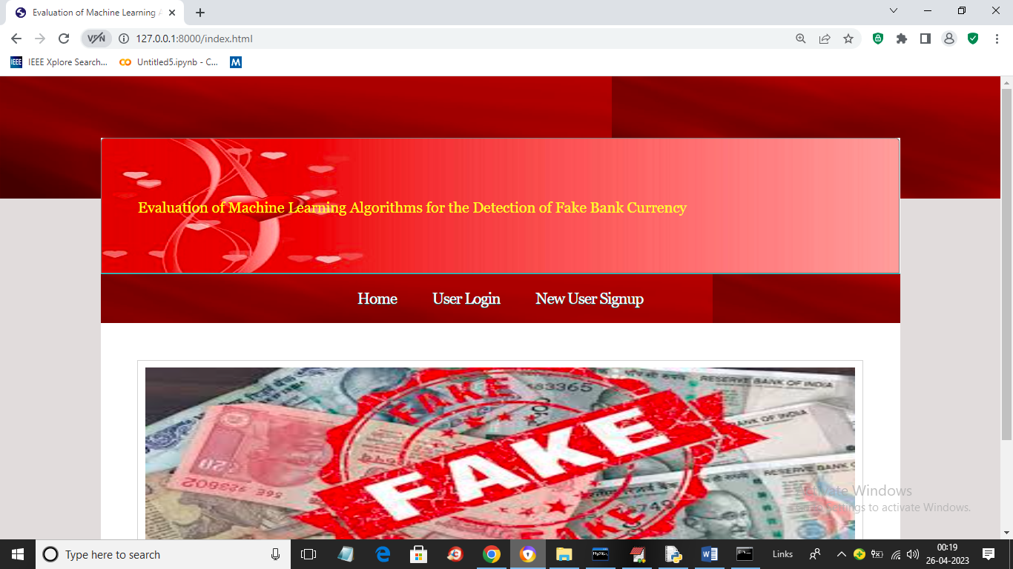

In above screen click on ‘New User Signup’ link to get below signup screen

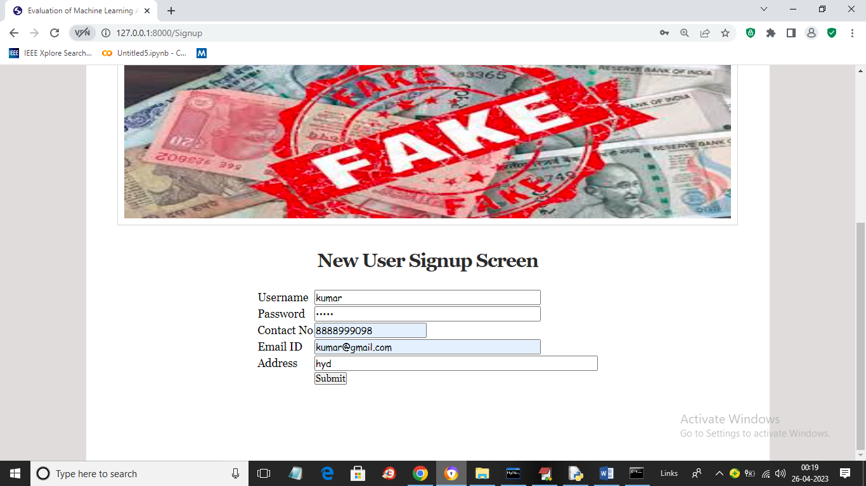

In above screen user is signing up and after pressing button will get below page

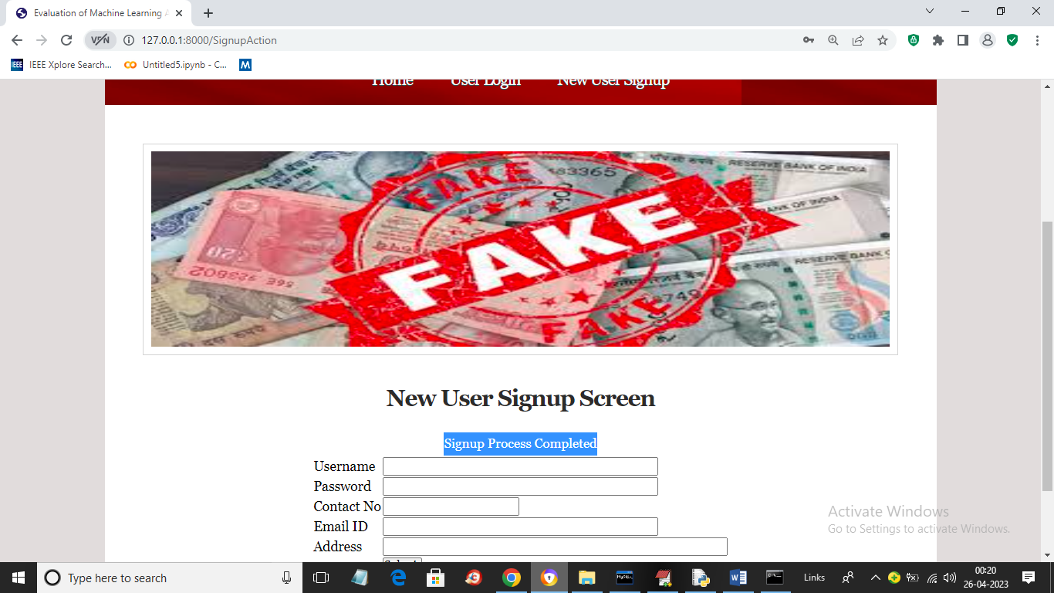

In above screen user signup task completed and now click on ‘User Login’ link to get below login screen

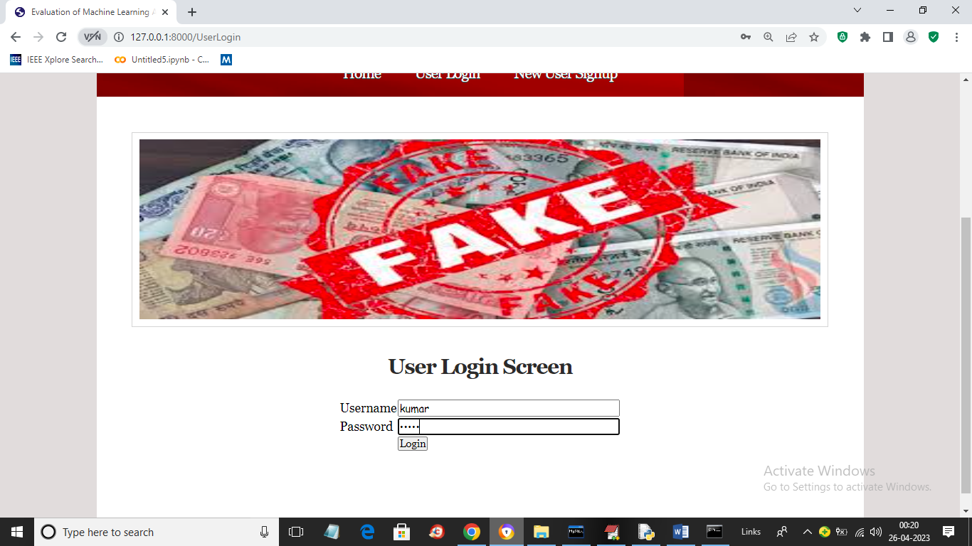

In above screen user is login and after login will get below page

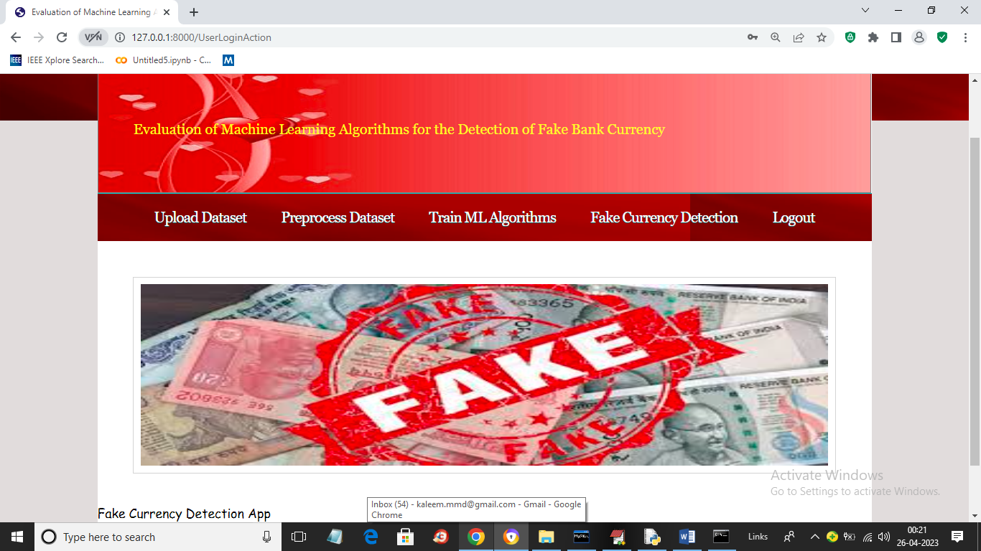

In above screen click on ‘Upload Dataset’ link to get below page

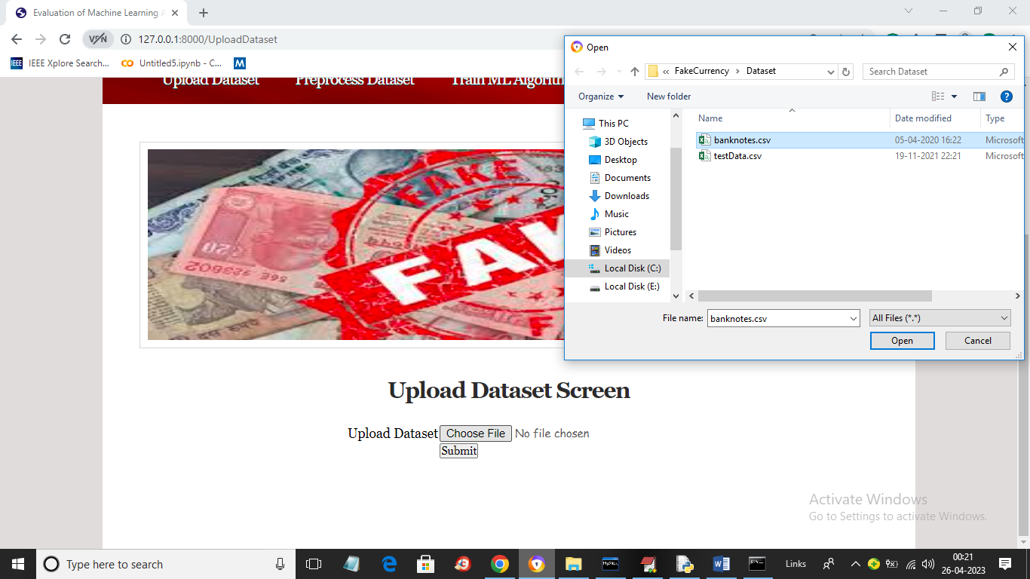

In above screen browse and upload ‘banknote.csv’ dataset file from cod dataset folder and then click on ‘Open’ button to load dataset and get below page

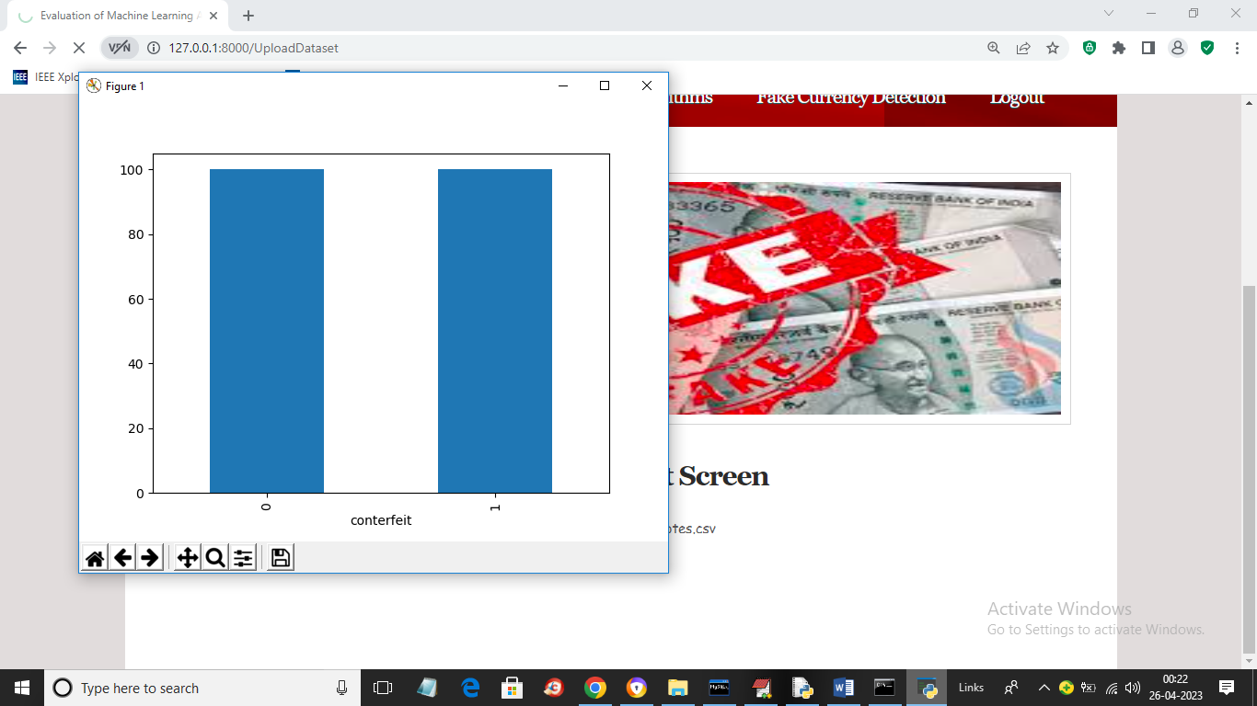

In above screen dataset loaded and in graph x-axis represents note type 0 (real) and 1 (fake) and y-axis represents number of records and now close above graph to get below page

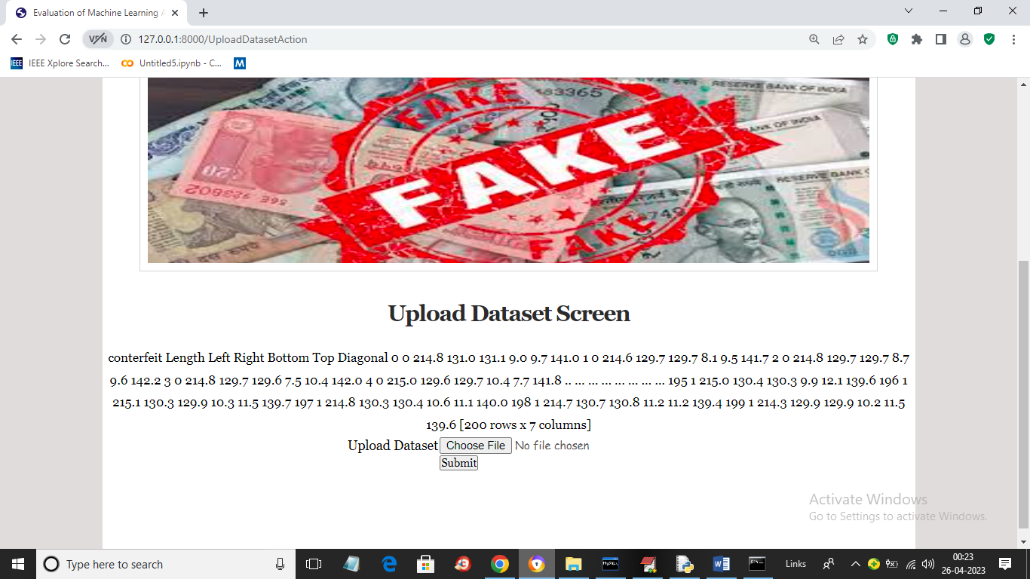

In above screen we can see some values from loaded dataset and now click on ‘Preprocess Dataset’ button to process dataset and get below page

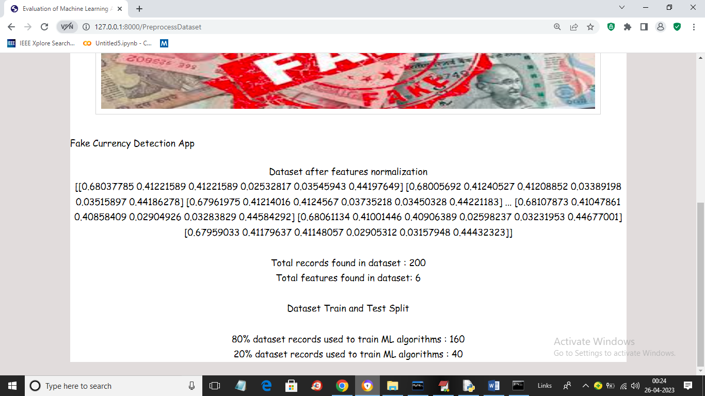

In above screen we can see processed dataset values and we can see total records and train and test records size. Now click on ‘Train ML’ link to train all ML algorithms and get below page

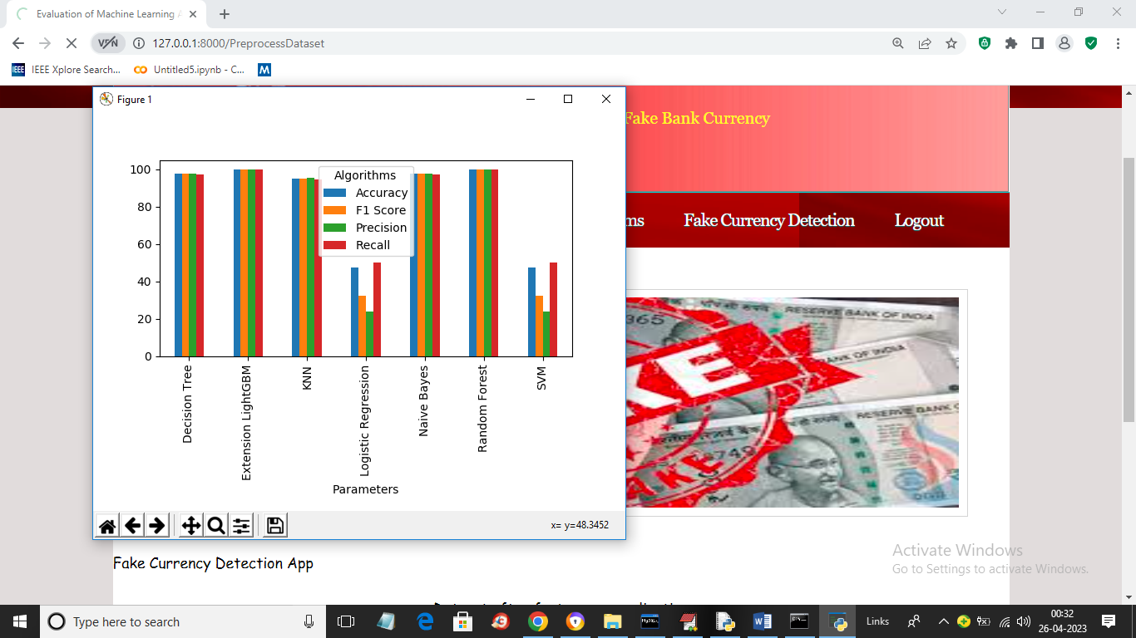

In above graph all ML algorithms got trained and in graph x-axis represents algorithm names and y-axis represents accuracy and other metrics in different colour bars and in all algorithms Extension got high accuracy and now close above graph to get below page

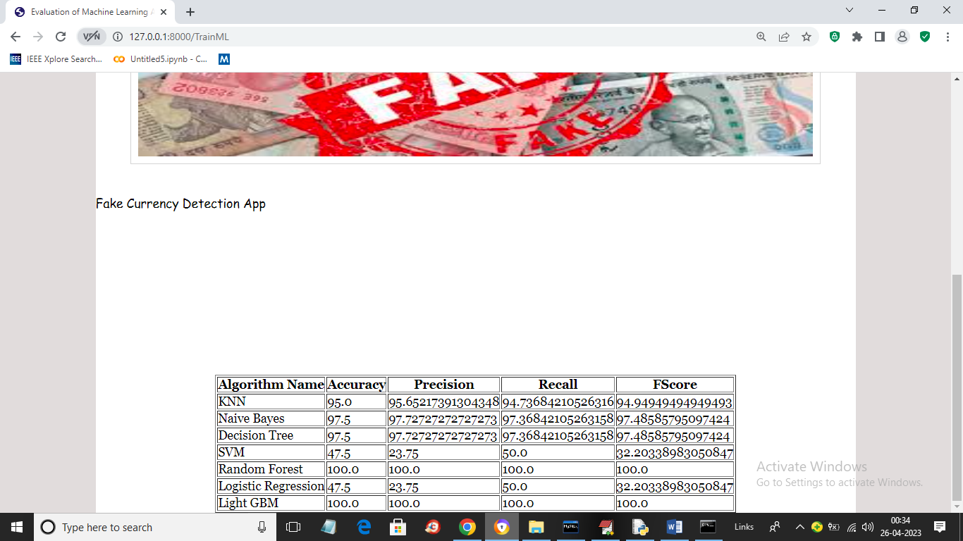

In above screen in tabular format we can see all algorithm performance and now click on ‘Fake Currency Detection’ link to get below page

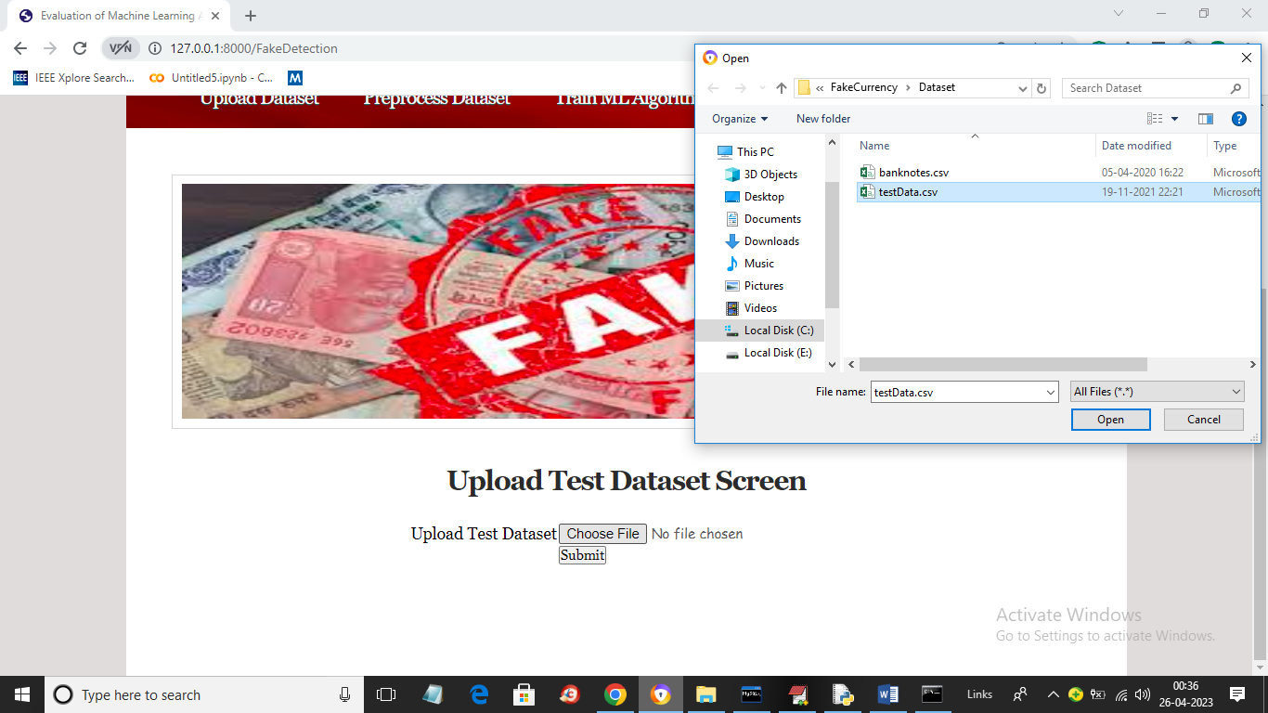

In above screen select and upload ‘testData.csv’ file and then click on ‘Open’ and ‘Submit’ button to get below page

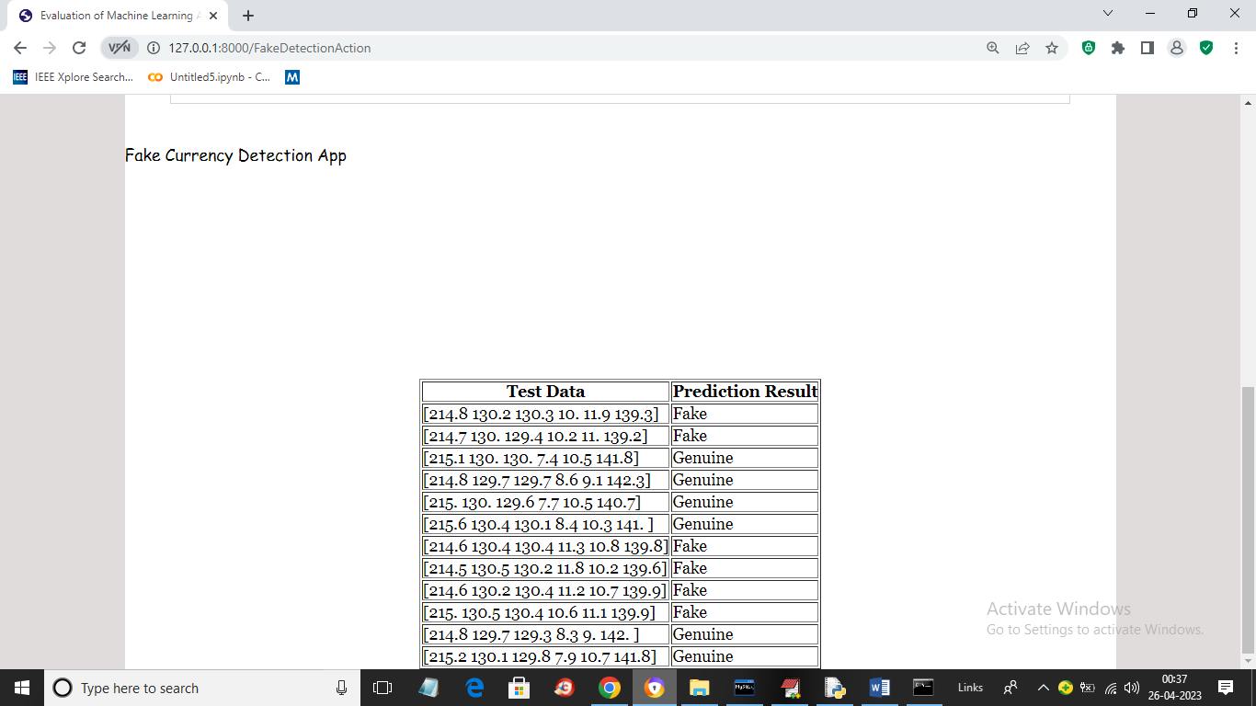

In above screen in ‘Test Data’ column we can see the test values and in second column we can see the predicted values as ‘Fake or Genuine’.

Similarly by following above screens you can run code